NAME OF STUDENT: ______________________________________________CLASS___________
2025 TERM 1 MZIMBA NORTH DISTRICT EXAMINATIONS

GEOGRAPHY FORM 2

(100 marks)
Thursday, 18th December Subject Number: J073
Time Allowed: 2 hours
(7:30am – 9:30 am)
Instructions:

- This paper contains 10 printed pages. Please check.
- This paper has three sections: A, B, and C.
- Follow instructions for each section carefully.
- Write your name in the spaces provided on all the pages of this paper before you start answering the questions.
- In the table provided on this page, tick against the question number you have answered.
- Hand in your question paper to the invigilator when time is called to stop writing.

Question  Number | Tick against the question if answered | Do not write in this column
1 - 20
21
22
23
24
25
26
27
28
29
30
 | Total marks

©MZN-T1-2025

SECTION A (20 marks)
Answer all the questions by encircling the letter corresponding to the correct answer.

- Which of the following is not a latitude?
- Equator
- Arctic circle
- Tropical of cancer
- International date line

- What name is given to a region of the earth that has adopted the same time?
- Standard time
- Time zone
- Greenwich meridian
- Equator

- How long will it take the earth to rotate for 135º if it completes its rotation of 360º in 24 hours?
- 9 hours
- 12 hours
- 24 hours
- 10 hours

- Which of the following planets supports life of all living things?
- Venus
- Mercury
- Earth
- Mars

- The following are features of hydrological cycle except.
- Transpiration
- Groundwater
- Vegetation
- Water masses

- Which of the following is used to represent relief on maps?
- Gorges
- Layer tinting
- Relief
- Gap
- Which of the following is a challenge associated with generation of Hydro-electricity in Malawi?
- Siltation of shire river
- Frequent blackout
- Interference by tall trees
- Accidents due to high voltage

- Which of the following is a line joining places of equal temperature?
- Isohyets
- Isobars
- Isotherms
- Isohels

- Which of the following is an instrument used to measure rainfall?
- Thermometer
- Wind vane
- Barometer
- Rain gauge

- The measure of steepness of a slope is called?
- Gradient
- Mountain
- Slope
- Relief

- What does the number at the centre of the wind rose stand for?
- Number of windy days
- Number of calm days
- Number of prevailing winds
- Number of sunny days

- The percentage of oxygen gas in the atmosphere is.
A.0.03 %
B.0.09 %
C. 21 %
D. 78 %
13. What is the population density of a town with an area of 400 km² and a total Population of 100,000 people?
A. 205 people /km²
B. 250 people/km²
C. 2500 people/km²
D. 25000 people/ km²

14. What happens when birth rate is higher than death rate?
- Mortality rate declines
- Mortality rate increases
- Population declines
- Population increases

15. Which of the following is a way of minimizing communication problems in Malawi?
- Regular maintenance
- Employing many people
- Inviting private sectors
- Introducing airlines

16. Which of the following latitude is located at 0⁰?
- Tropic of Capricorn
- Tropic of cancer
- Arctic circle
- Equator

17. Which of the following are the results of the revolution of the earth?
- Varying length of day and night
- Seasons of the year
- Deflection of ocean currents
- Day and night
- 1 and 2
- 1 and 3
- 2 and 4
- 3 and 4

18. What name is given to a landform with a depression between two hills?
- Spur
- Gap
- Slope
- Gradient

19. Which of the following explains intermittent drainage pattern of a river?
- River starts from a point
- Tributaries join to main streams at almost right angles
- The rivers disappear and appear again when they pass through swaps
- The pattern has appearance like that of branches of a tree

20. Which of the following is an example of a riverine feature?
- Floodplains
- Relief
- Contour interval
- Slope

SECTION B (50 marks)
Figure 1 is a map of Lisangadzi. Use it to answer questions that follow.
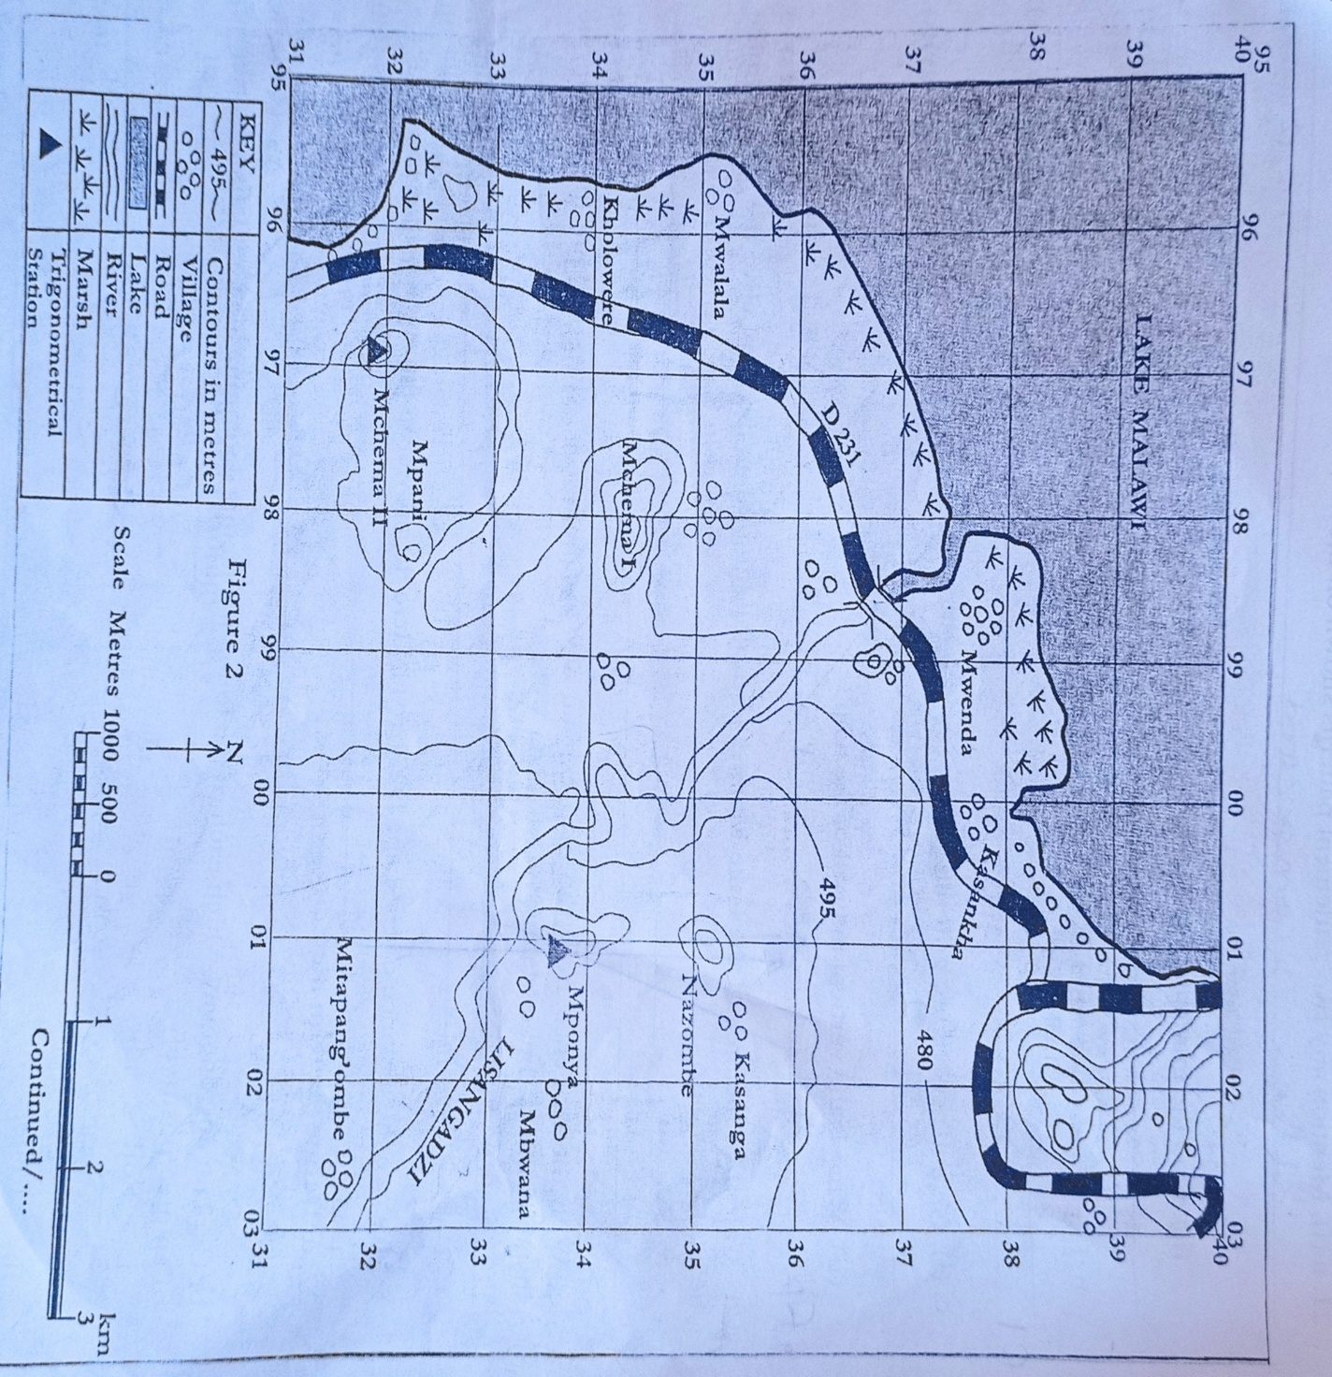
- a. (i) Identify two ways how relief features have been represented on a map.
__________________________________________________________________________________________________________________________________________ (2 marks)
(ii) What is the contour interval of the map? (1 mark)
______________________________________________________________________
b. Give the four-figure grid reference of Mwalala village. (1 mark)
__________________________________________________________________________
c. Find the six figure grid reference of the trigonometrical station near Mponya village ____________________________________________________________ (2 marks)
d. Mention any two settlements patterns shown on the map.
____________________________________________________________ (1 mark)
____________________________________________________________ (1 mark)
e. Calculate the area of Lake Malawi. Give the answer to the nearest kilometre.

(4 marks)
f. Identify one way of expressing scale that has been used on the map. (1 mark) ______________________________________________________________________________
g. Explain one economic activity that is most likely to be carried out at Kholowere Village. (2 marks)
____________________________________________________________________________________________________________________________________________________________
h. State any two means of transport used by people in the area (2 marks)
____________________________________________________________________________________________________________________________________________________________
i. Find the bearing of Kasanga from Trigonometrical station in 0133 (2 marks)
______________________________________________________________________________

22 a. Define the term migration? (1 mark)
____________________________________________________________________________________________________________________________________________________________
b. Mention any two push factors of migration. (2 marks)
____________________________________________________________________________________________________________________________________________________________
23. Figure 2 shows type of rainfall. Use it to answer the questions that follow.

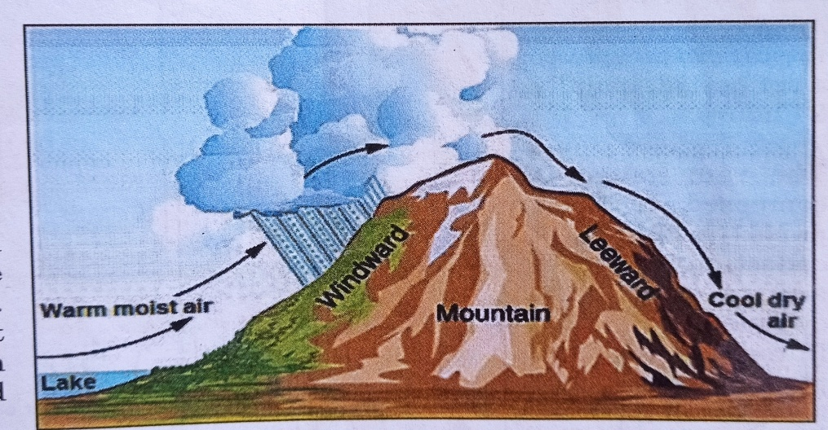

a. Identify the type of rainfall. (1 mark)
______________________________________________________________________________

b. Explain briefly how the type of rainfall mentioned above is formed (3 marks)
________________________________________________________________________________________________________________________________________________________________________________________________________________________________________________________________________________________________________________________ 24. a. State two main components of the environment (2 marks)
____________________________________________________________________________________________________________________________________________________________
b. Identify one problem associated with water in an environment (1 mark)
______________________________________________________________________________
25. a. State any two ways of conserving soil. (2 marks)
__________________________________________________________________________________________________________________________________________________________________________________________________________________________________________

b. Describe how the following factors influence population distribution.
1. Soil (2 marks)
____________________________________________________________________________________________________________________________________________________________
2. Climate (2 marks)
____________________________________________________________________________________________________________________________________________________________
26. a. Define land use? (1 mark)
____________________________________________________________________________________________________________________________________________________________
b. Explain any two factors that influence the drainage pattern of a river in an area (4 marks)
________________________________________________________________________________________________________________________________________________________________________________________________________________________________________________________________________________________________________________________
27 a. State any two characteristics of longitudes (2 marks)
__________________________________________________________________________________________________________________________________________________________________________________________________________________________________________
b. What will be the local time of a place 40º East of the Greenwich Meridian, when the time at longitude 140⁰ west is 4:00 am? (3 marks)

28 a. Why is Pluto no longer regarded as a planet (give any one reason). (1 mark)
______________________________________________________________________________
b. Describe any two developments related to the solar system (4 marks)
________________________________________________________________________________________________________________________________________________________________________________________________________________________________________________________________________________________________________________________
SECTION C (30 marks)
-Answer both questions in this section in an essay form in the spaces provided.
29 a. Describe any four problems of high population growth.
__________________________________________________________________________________________________________________________________________________________________________________________________________________________________________________________________________________________________________________________________________________________________________________________________________________________________________________________________________________________________________________________________________________________________________________________________________________________________________________________________________________________________________________________________________________________________________________________________________________________________________________________________________________________________________________________________________________________________________________________________________________________________________________________________________________________________________________________________________________________________________________________________________________________________________________________________________________________________________________________________________________________________________________________________________________________________________________________________________________________________________________________________________
(8 marks)
b. Explain any three ways in which natural resources are being mismanaged in Malawi.
______________________________________________________________________________________________________________________________________________________________________________________________________________________________________________________________________________________________________________________________________________________________________________________________________________________________________________________________________________________________________________________________________________________________________________________________________________________________________________________________________________________________________________________________(7 marks)
30. a. Describe any four causes of natural disasters in Malawi.
_________________________________________________________________________________________________________________________________________________________________________________________________________________________________________________________________________________________________________________________________________________________________________________________________________________________________________________________________________________________________________________________________________________________________________________________________________________________________________________________________________________________________________________________________________________________________________________________________________________________________________________________________________________________________________________________________________________________________________________________________________________________________________________________________________________________________________________________________________________________________________________________________________________________________________________________________________________________________________________________________________________________________________________________________________________________________________________________________________________________________________________________________ (9 marks)
b. Discuss any three results of the rotation of the earth.
______________________________________________________________________________________________________________________________________________________________________________________________________________________________________________________________________________________________________________________________________________________________________________________________________________________________________________________________________________________________________________________________________________________________________________________________________________________________________________________________________________________________________________________________________________________________________________________________________________________________________________________________________________________________________________________________________________________________________________________________________________________________________________________________________________________________________________________________________________________________________________________________________________________________________________________________________________________________________________________________________________________________________________ (6 marks)

END OF QUESTION PAPER

